# Amazon Simple Storage Service (S3)

## Steps

Create S3 Bucket

Upload a file to an S3 bucket

Change Bucket Permission

Create a Bucket Policy

Test Public Access

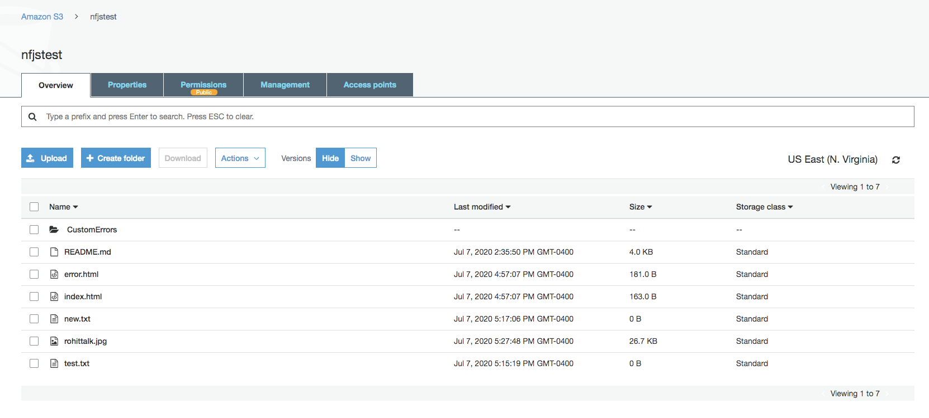

Copy files from the files directory

Block Public Access is off

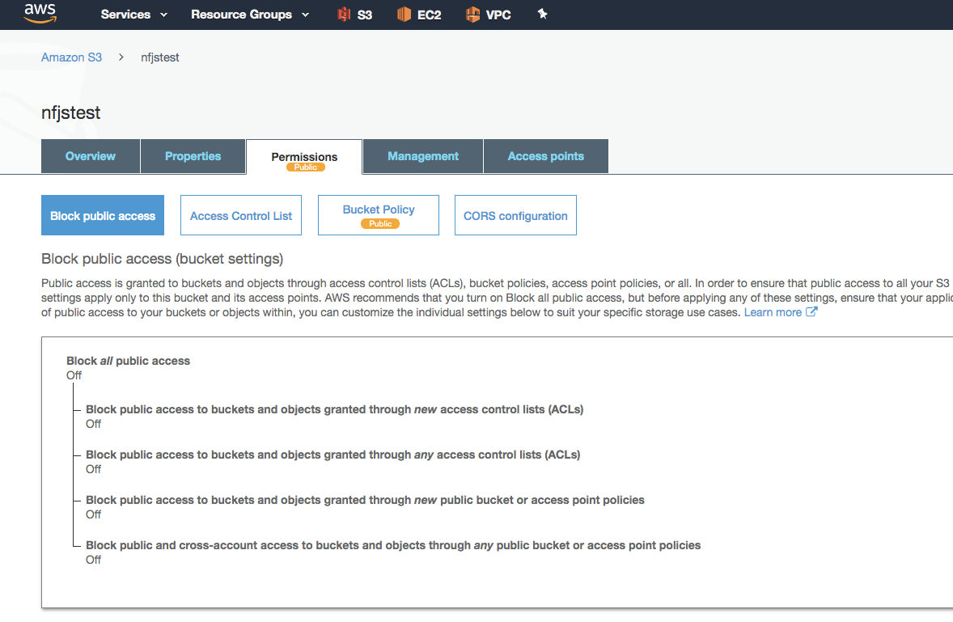

**Bucket policy creation**

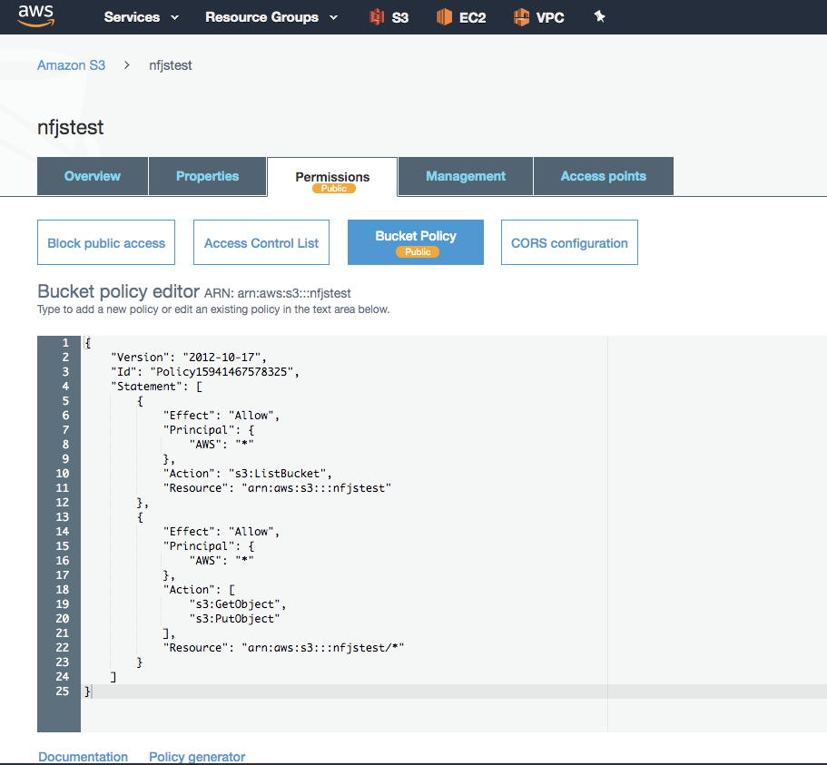

{

"Version": "2012-10-17",

"Id": "Policy15941467578325",

"Statement": [

{

"Effect": "Allow",

"Principal": {

"AWS": "*"

},

"Action": "s3:ListBucket",

"Resource": "arn:aws:s3:::nfjstest"

},

{

"Effect": "Allow",

"Principal": {

"AWS": "*"

},

"Action": [

"s3:GetObject",

"s3:PutObject"

],

"Resource": "arn:aws:s3:::nfjstest/*"

}

]

}

**Creating static Web Site**

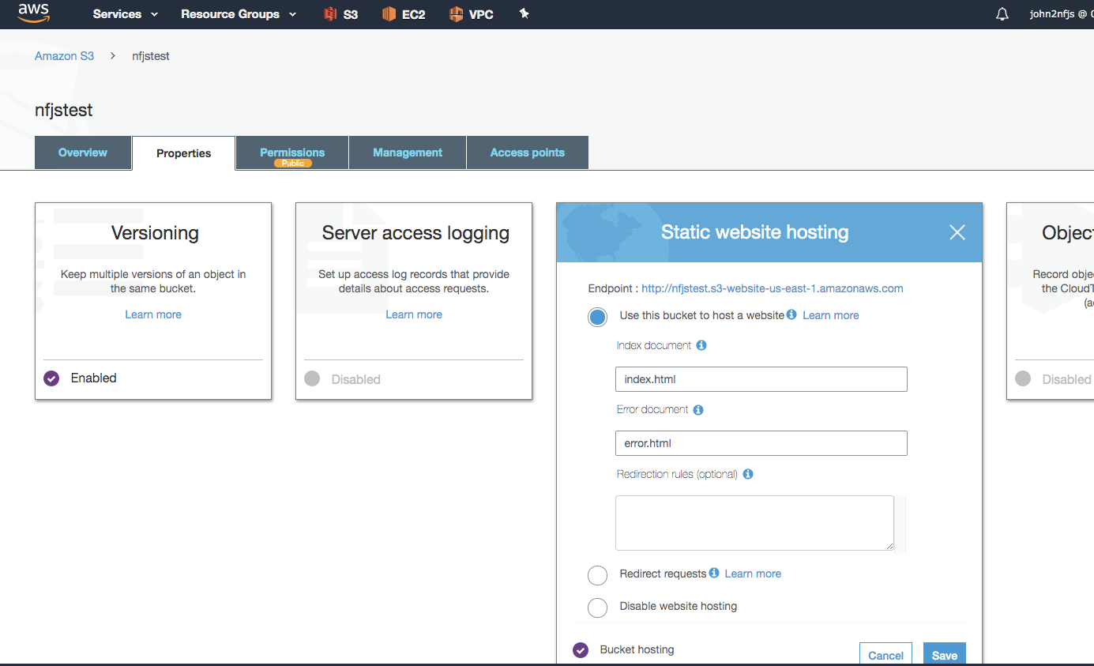

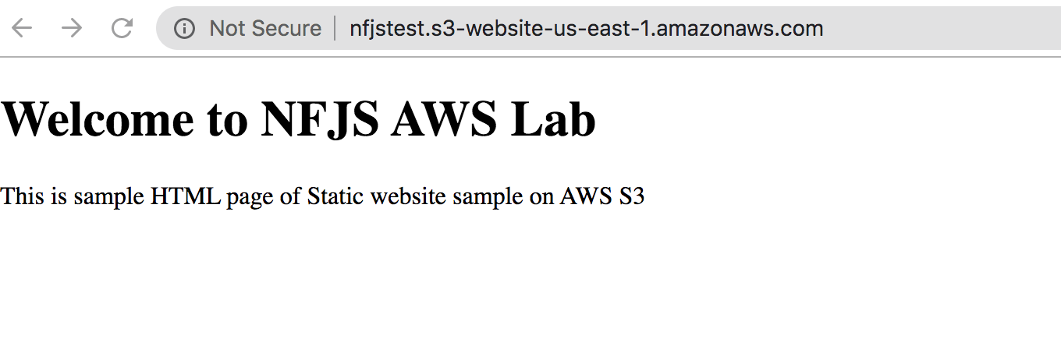

## Lifecycle Policy

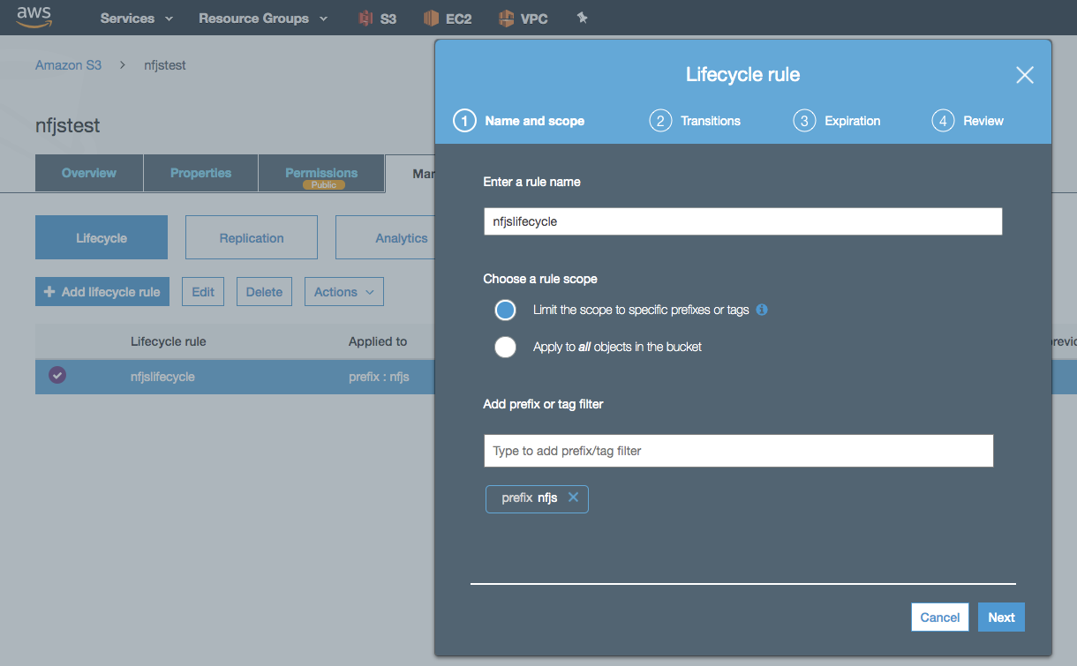

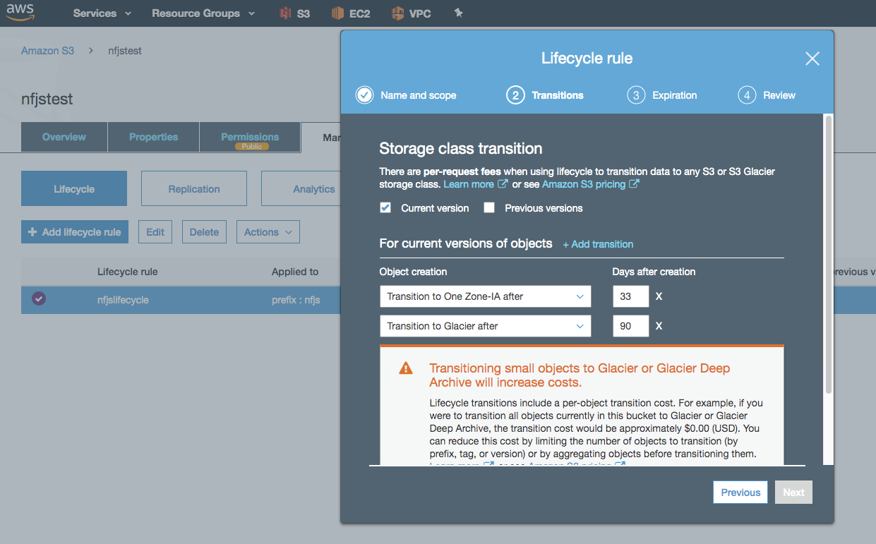

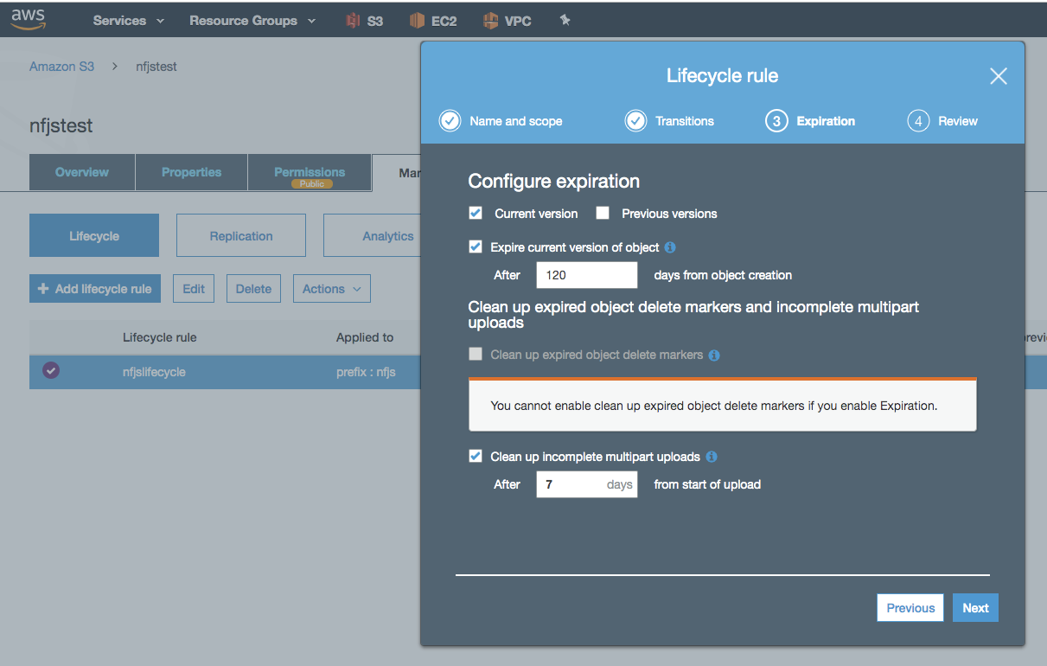

## Replication

